|  |  |  |  |  |
| --- | --- | --- | --- | --- |
| **Issue No.** | **Type** | **+/-** | **Priority(0-4)** | **Frame/Ref** |
| 1 | Literacy | - | 2 | 1 |
| 2 | Slow connection | - | 4 | 2 |
| 3 | Visual | - | 3 | 3 |
| 4 | Visual | - | 3 | 4 |

1. verifying that the syntax of the pages is correct.

Accessibility features: Literacy

Accessibility issue: When users are writing something to express ideas or ask for help，LMS can not assist them check and correct their grammar problem in texts，which make their posted texts sometimes confusing.

Accessibility Solution : Shown in the following sketches.

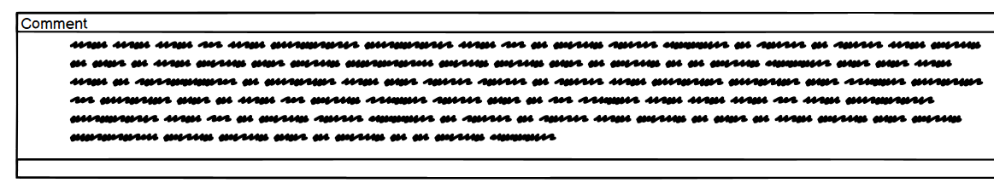

Turns to

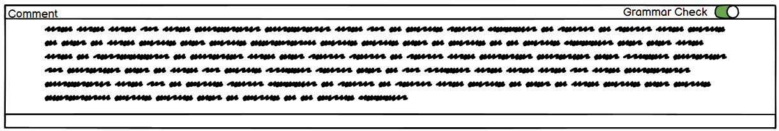

Task Scenarios: Alex is a new 23-years-old student in UNSW and this is his first year of postgraduate life in Australia. So he hasn’t got familiar with English communication with other students and lecturers. And due to the COVID-19, he had to finish the course online. During the period of watching recording or live stream, he wanted to post some questions on comment section or send email to lecturer, and he worried about some grammar mistakes happened in his comments or emails,which might cause readers‘misunderstanding.

2. Provide text-only web pages for users with poor network (no image loading)

Accessibility features: Slow connection

Accessibility issue: When users are using Learning Management System in an area which has slow connection network, users can't load all the content of the page quickly. It will prevent users from getting basic information.

Accessibility Solution : Shown in the following sketches.

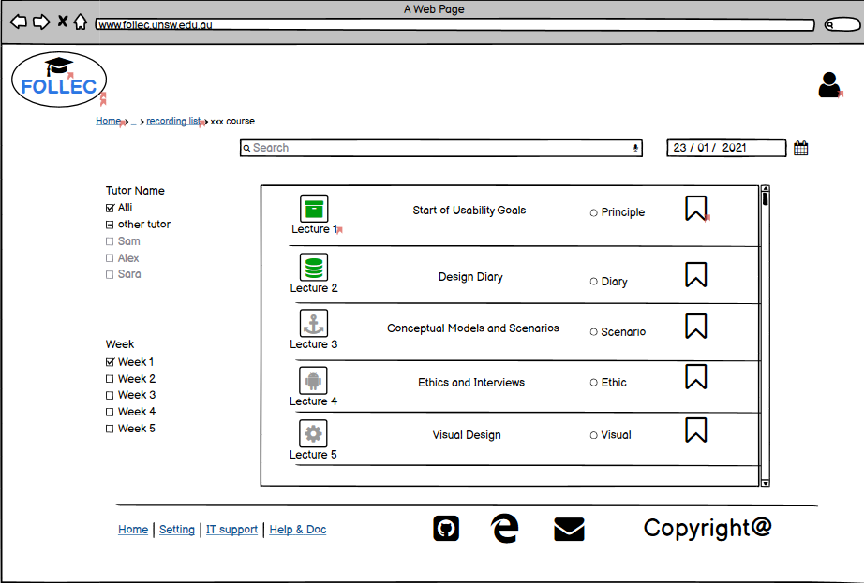

Turns to

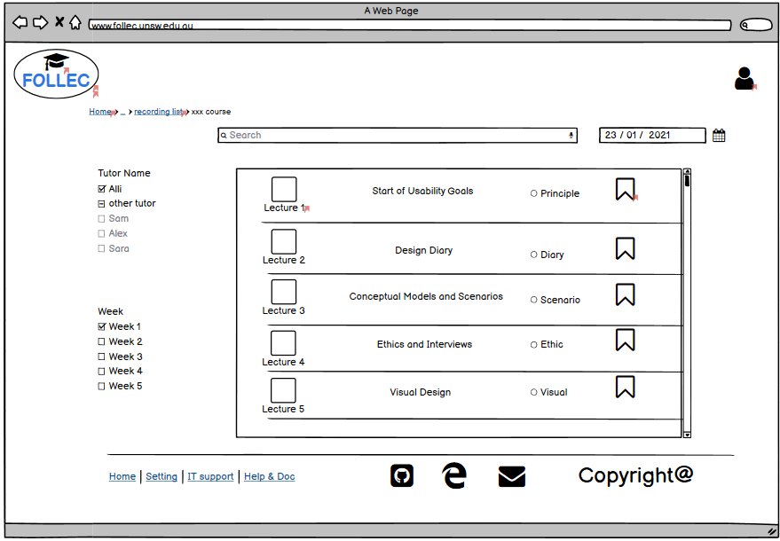

Task Scenarios: Ms. Kaseem is a part-time student in UNSW and she has to take lectures in different place because her work is busy and always on a business trip. Sometimes she has to stay at one place which has slow connection network, she can still get basic information about lectures and keep learning.

3.Attach Screen Readers Function to the system and provide equivalent alternative content for the visually impaired users.

Accessibility features: Visual

Accessibility issue: When visually impaired users are using Learning Management System, they always feel depressed because browsing text or image content is difficult for them. All contents which needed to be seen are obstacles for them to understand the website.

Accessibility Solution : Shown in the following sketches.

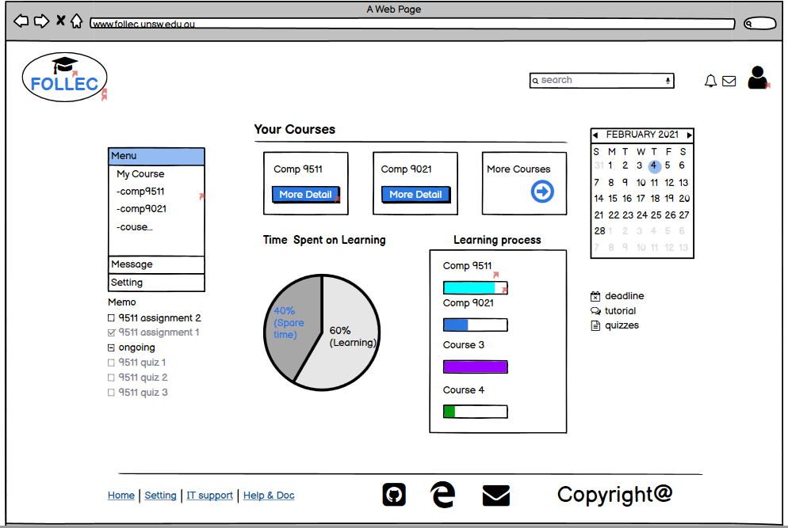

Turns to

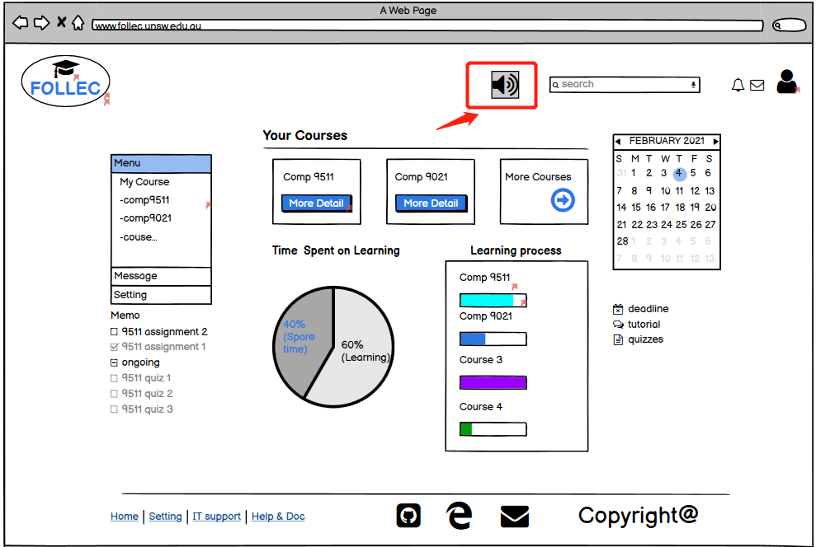

Task Scenarios: Harry is a visually impaired student in UNSW. In the past time, every time when he log in the homepage of the learning management system，he feels difficult to distinguish the content which needed to be seen. But after the screen readers function is added to the system, Harry can use the system more efficiently than before and save a lot of time.

4. Provide color blind mode color design page for color blind user

Accessibility features: Visual

Accessibility issue: When color blind users(red&green) are using Learning Management System, they will be confused if the whole website color layout uses many red and green color, and it will cause users doing many wrong operation for this reason.

Accessibility Solution : Shown in the following sketches.



Turns to

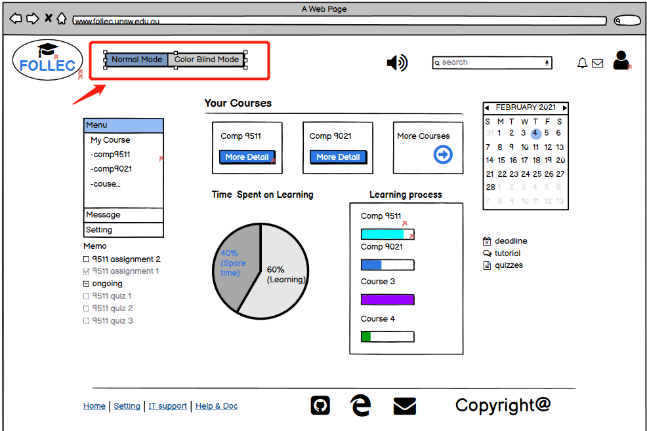

Task Scenarios:Terry is a color blind student in UNSW. He sometimes feel confused about the time spent on learning because it use red and green to distinguish spare time and learning time. To solve the problem，he switch the webpage mode from normal mode to color blind mode, then he can easily distinguish the content because color blind mode change the color layout of pie chart.